Junie B. Jones: The Musical
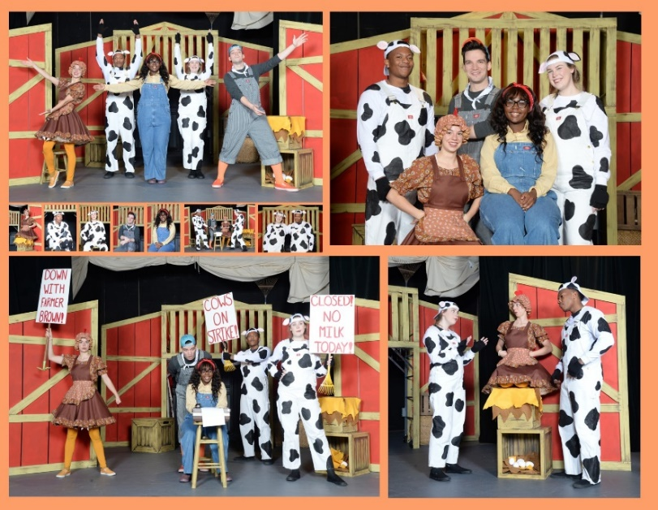

The Cast of Junie B. Jones: The Musical
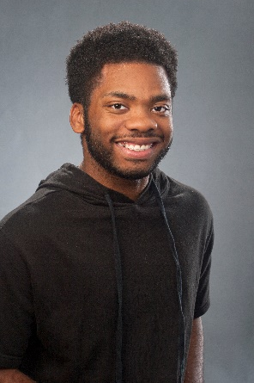
BAXTER EVANS III (Herb, Mr.Scary) is an actor and combatant from Clinton. Miss. where he went to Hinds Community College, and performed in shows called Water Engine and Bus Stop. Evans then moved to Hattiesburg, Miss. to study theatre at the University of Southern Mississippi, performing in the shows Once in a Lifetime, She Kills Monsters, The Addams Family, and Macbeth. While at USM, Evans received a KCATCF nomination, allowing him to travel to the KCATCF Region IV back in February 2023. He also served in Alpha Psi Omega, Harlem (a BIPOC theatre club), and Skip the Script (an improv club). Evans is excited to come back home to learn more and to work for a professional theatre company and is excited for what comes!

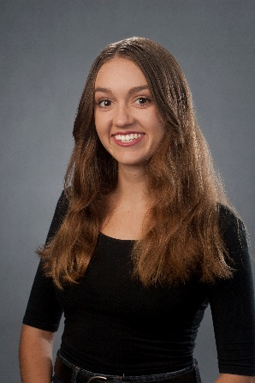
MORGAN McKAY (Junie B. Jones) is a recent graduate from Liberty University with a BFA in musical theatre, where some of her favorite roles included Harriet Smith in the musical Emma, Charlotte in Oliver!, and Rebecca Gibbs in Our Town. In 2022, she was the co-director of creative and performing arts at Sandy Hill Summer Camp, and this past summer she was an actor and improv teacher at WinShape Camps for Girls in Georgia. She is looking forward to working with such a wonderful group of artists at New Stage Theatre. She would like to thank her parents for all of their love and support, and God for His unconditional love and the gifts and passion He has given her.

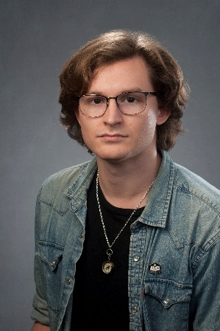
PAUL PELLETIER JR (Daddy, Sheldon, Jose, and Bobbie Jean Piper) is an actor, singer, playwright, and combatant. Pelletier is also a graduate of The University of Central Florida, having graduated with a BFA in acting. Over the course of his 7+ year career in the theatre, Pelletier has been a part of several fantastic productions. Ranging from spectacular musicals like RENT, Little Women the Musical, and Into The Woods, to classic pieces such as As You Like It, Much Ado About Nothing, and Indecent. Pelletier is also a huge advocate for new voices and pieces in the theatre, having been both a playwright and actor for companies such as Project Spotlight and The Orlando Fringe Festival, organizations that help produce first time playwrights and independent company’s works. Pelletier seeks to bring laughter to those he meets, both on stage and off it, with a quick joke and chipper outlook on life. When not on the stage, he is an avid Dungeons & Dragons player, having been in games lasting over four years. He also enjoys drawing, video games, swimming, and cooking. Pelletier is incredibly grateful to be a part of the New Stage Artist Associate program, and can’t wait to make new and exciting art with such amazing individuals! www.paulpelletierjr.com

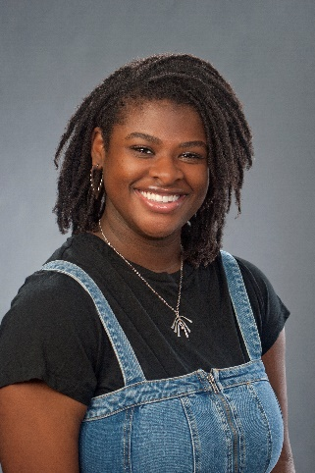
JADE KRYSTAL DYER (Lucille,May, Grace, Mother and Mrs. Gutzman) is a graduate of Florida State University with a bachelor of arts in theatre on a performance track. Some of her performance experience includes Hair the Musical, Julius Caesar, Sweet Charity, and The True Story of the Three Little Pigs. When not on stage, Dyer also enjoys taking on other roles in entertainment, such as writing, producing, and directing an original Choreopoem titled Dear, [BLANK]; Love, Anonymous as well as acting as an associate producer and production coordinator on an indie television series called Tri- County. As an actor and a person, Dyer prioritizes kindness, respect, and enjoyment for all! She is ecstatic to be a part of the New Stage team, and all of the wonderful things that are yet to come! You can find her on Instagram @jade.krystalll

The 2022-2023 New Stage Education Team
XERRON X. MINGO (Education Director/ Director/ Choreographer) is a graduate of Florida A&M University. Born in St.Thomas, Virgin Islands and recently resided in New York City where he worked as a health & safety manager for productions on Apple TV and HGtv. He also worked as a testing secretary and production coordinator for television shows with LIONSGATE and Apple Music Reviews. For the past ten summers, Mingo has worked at Raquette Lake Camps teaching musical theatre to students from all across the world. He recently made a return to the stage and served as choreographer while playing the role of Fezziwig in A Christmas Carol at New Stage in 2021. He has worked professionally at a plethora of regional theatres in a handful of states. Some of his past credits include Matilda (Rudolpho/Choreographer), Hell In High Water (Cephus), Sister Act (TJ), Shakespeare in Love (Wabash/Frees), and Disney’s Beauty & The Beast (Monsieur Dar’que). Moreover, The Wiz (The Lion) and The Hot Mikado (Pooh-Bah) at the GLOW Lyric Theatre in Greenville, S.C. He was in Black Nativity (Narrator) at Westcoast Black Theatre Troupe, The Great Society at Asolo Rep, and Hairspray (Gilbert) at American Stage. Mingo continues to live in the Light and could not be more blessed to do so as he embarks on this new journey as education director at New Stage Theatre.

BETTY WONG (Education Consultant) begins her 16th season at New Stage. She continues to enjoy traveling to schools and towns throughout the state with the Professional Apprentice Company to provide live theatre experiences for students and adults of all ages. When not on the road, you can find her in the box office. She has also served for many years as a volunteer in other areas of the theatre. Her professional work experiences in education and her passion for live theatre have contributed to the growth and expansion of New Stage’s Education Department. She has served as a consultant to school districts throughout the state of Mississippi. Wong has a B.S. in Educational Psychology from Mississippi State University, a M.Ed. from Delta State University, and recently won the 2019 Exemplary Arts Service Award from the Mississippi Alliance for Arts Education.

VERNELL ALLEN (Directing Associate/ Assistant Director) is a New York based producer, director, writer, and stage manager originally born in Mississippi. He’s directed and managed two touring shows, Theatre for Young Audiences, community theatre, and collegiate plays, the most recent being All American Boys by Jody Alperin and Vicky Crouch. He also served as second AD for Wes Miller’s A Day to Die starring Bruce Willis and Dallas Jackson’s The System starring Tyrese Gibson. Allen is an alumnus of Mississippi State University and the Mississippi School of the Arts, and remains a student of the game.

The Production Team

Artistic Director | Francine Thomas Reynolds
Education Director/Director/Chorographer | Xerron X Mingo
Assistant Director/ Directing Associate | Vernell Allen
Set Designer | Antonio Juarez
Costume Designer | Caleb Blackwell
Sound Designer | Alberto Meza
Props Master | Jenna Kahley
Education Consultant | Betty Wong

#JunieBJones
#NewStageTheatre
#NewStageEd
#MSArtsEd
#ArtsEd

www.newstagetheatre.com/educate

