
IMMEDIATE RELEASE
Contact: Joey Nelms
Office (601) 948-3533 ext. 225
jnelms@newstagetheatre.com

1100 Carlisle Street
Jackson, Miss. 39202
Phone (601) 948-3533

New Stage Theatre presents the smash hit comedy
The Play That Goes Wrong

September 9 – 21, 2025 | Sponsored by Linda and John Schmidt

Click for publicity photos: The Play That Goes Wrong | New Stage Theatre

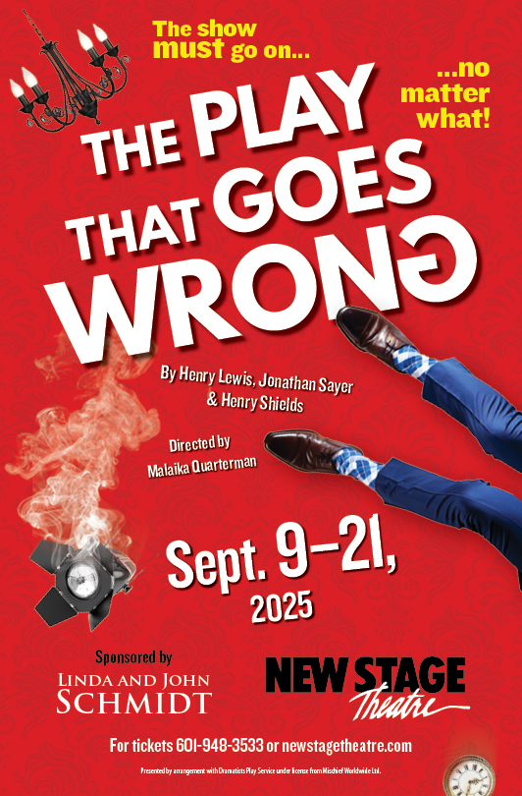JACKSON— The show must go on… no matter what! New Stage Theatre brings gut busting laughs and unimaginable gags in smash hit comedy, The Play That Goes Wrong, September 9 – 21. Welcome to opening night of the Cornley University Drama Society’s newest production, The Murder at Haversham Manor, where things are quickly going from bad to utterly disastrous. This 1920s whodunit has everything you never wanted in a show—an unconscious leading lady, a corpse that can’t play dead, and actors who trip over everything (including their lines). Nevertheless, the accident-prone thespians battle against all odds to make it through to their final curtain call, with hilarious consequences! Part Monty Python, part Sherlock Holmes, this Olivier Award– winning comedy is a global phenomenon that’s guaranteed to leave you aching with laughter!

Performances are scheduled for September 9 - 13, September 16, and September 18 - 20 at 7:00 p.m., with matinee performances on September 14 and 21 at 2:00 p.m., and a special Mid-Week Matinee on Wednesday, September 17 at 1:00 p.m for those seeking a daytime theatre experience. There is also a special student matinee Thursday, September 18 at 10:00 a.m. Educators should call the box office to make a reservation. Tickets are $35.00, with discounts available for students, senior citizens, military, and groups. Tickets can be purchased at the box office, by calling (601) 948-3533, or online at www.newstagetheatre.com. Security patrols will be present during all performances. The Play That Goes Wrong is recommended for ages 8+.
The set for The Play That Goes Wrong has been constructed from the ground up and is full of surprises and practical gags sure to keep audiences on the edge of their seats and rolling with laughter.

Artistic Director, Francine Reynolds said, “The Play That Goes Wrong is the perfect play to open the 60th Anniversary Season at New Stage Theatre. A very talented group of theatre artists and comedic actors has been assembled for the show and we can’t wait to welcome audiences to this love letter to theater. It might be The Play That Goes Wrong, but I know with this brilliant company nothing will go wrong… unless it is supposed to!”

The cast includes:
Donovan Lockett as Annie Twilloil (Pennsylvania). Seth Rodivich (Louisiana), Michaela Williams (Georgia), Tarvorius House (Alabama), and Hannah Beth Rollman (Jackson), as Stage Hands. Slade Haney as Trevor Watson (Clinton), Cliff Bowen as Chris Bean (Jackson), Michael Kinslow as Jonathan Harris (Mississippi), Drew Stark as Robert Grove (Alabama), John Howell as Dennis Tyde (Jackson), Jeff Rowan* as Max Bennett (NYC), and Lauren Parkinson as Sandra Wilkinson (Jackson). *Indicates actor is a member of Actors’ Equity Association.

Don’t miss this hilarious comedy that’s sure to bring you to tears. Whether you're a longtime patron or new to New Stage Theatre, The Play That Goes Wrong is a must-see theatrical event!

Discount Nights

PAY WHAT YOU WANT NIGHT: Patrons can come to the box office beginning at 6:00pm on Tuesday, September 9 and name their price at the door. Valid for the September 9 performance only. Subject to availability ($5 minimum on all credit card purchases)

STUDENT RUSH DISCOUNT: One hour prior to curtain for ANY performance, students with a current academic ID may purchase an available seat for $10. Limit one ticket per ID.

YOUTH NIGHT: Youth 18 and under can reserve $15 tickets for the performance on Friday, September 12. This discount is only available in person or by calling the box office and mentioning “youth night” for the discount.

MISSISSIPPI THEATRE NIGHT: To celebrate Mississippi’s thriving theatre community, anyone who mentions ‘Mississippi Theatre” can reserve $15 tickets for the performance on Friday, September 19. This discount is only available by calling the box office and mentioning “Mississippi Theatre” for the discount.

Schedule & Ticket Information

Where:
1100 Carlisle Street, Jackson MS 39202

Dates:
Open: September 9, 2025; Close: September 21, 2025

Performance Times:
September 9 – 13, September 16, September 18 – 20 at 7:00 pm
September 14 & September 21 at 2:00 pm
September 17 at 1:00 pm
September 18 at 10:00 am (classes/students only)

Tickets:
$35; seniors/students/military $30

Box Office:
Telephone: 601-948-3533
Online: www.newstagetheatre.com
Email: tickets@newstagetheatre.com
Hours: Monday-Friday from 10 a.m. – 5 p.m.

Hours During Show:
Tuesday thru Friday: 10 am - 7:00 pm
Saturday: 4 pm – 7 pm; Sunday: 1 pm - 2 pm

Tickets Online:
Tickets may be purchased 24 hours a day, seven days a week at www.newstagetheatre.com (a per-ticket service fee of $3 applies to all online purchases)
###

Director Malaika Quarterman
Stage Manager Rachel Boudreaux
Production Manager Casey Nelms
Co-Scenic Designer/Technical Director Richard Lawrence
Co-Scenic Designer Dave Ellis
Co-Scenic Designer Jimmy Robertson
Costume Designer Anna Hillbery
Lighting Designer Andrew Prince
Sound Designer Callie Jackson
Properties Designer/Scenic Charge Artist Michael Montgomery
Assistant Technical Director/Lead Electrician Antonio Juarez
Costume Assistant Lamana Stringfellow
Fight/Intimacy Consultant Caitlyn Herzlinger
Fight Director Drew Stark
Dialect Coach Jamie Shannon Ferguson
Assistant Director Kymbrianna Griggs

